The SDKClientSharp project is the main project, and the example in this solution is used by general customers to actively connect devices in the LAN. Hasdkwrapper is the main project, and what customers need to refer to is him (remember to copy lib or lib64 to the target directory). SDKClientSharp mainly uses WinForm program to expose the function to customers for demonstration. The user interface is as follows:

Step1: initialize the SDK
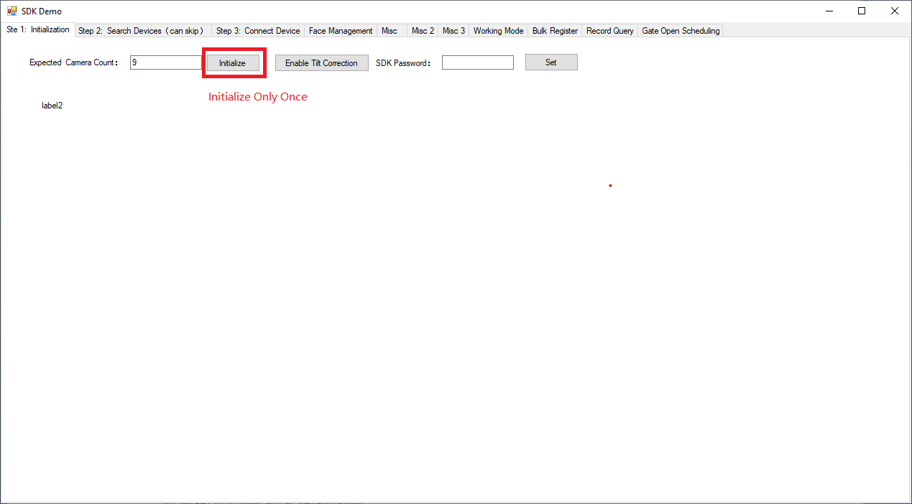

Step 2: search cameras (can skip this step)
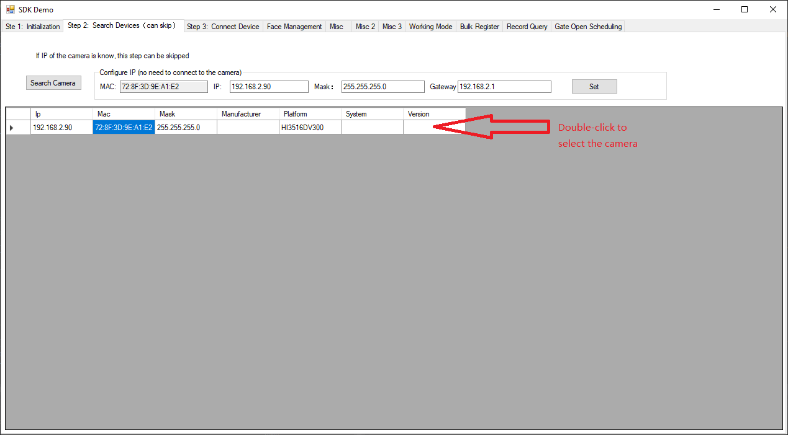

Step 3: connect to the camera
